Assignment 5.2

1. Obtain the elements of the union between two character vectors.

vec1 = c(rownames(mtcars[1:15,]))

vec2 = c(rownames(mtcars[10:32,]))

Solution: -

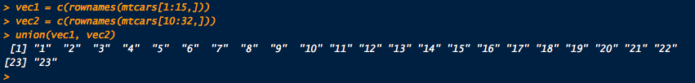

2. Get those elements that are common to both vectors.

vec1 = c(rownames(mtcars[1:15,]))

vec2 = c(rownames(mtcars[10:32,]))

Solution: -

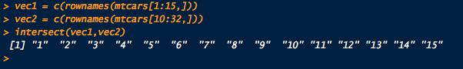

3. Get the difference of the elements between two character vectors.

vec1 = c(rownames(mtcars[1:15,]))

vec2 = c(rownames(mtcars[10:32,]))

Solution: -

